Tonight's Cast

Emcees Brandon & Dan
Trixie Jordan
Frank N. Furter Diego
Brad Majors Jesus
Janet Weiss Megan
Riff Raff Steffan
Magenta Laura
Columbia Mandi
Dr. Scott Tim
Eddie Wade
Rocky Jason
Crim Leif
Phantom Paco & Dan

Transylvanians

Cheryl Poncho Peter
Jordan Carlos Kayla

Midnight Mafioso

Stage Director: Brandon Stage Director: Mandi Technical Director: Zac Inventory: Aleah
Tranny Coordinator: Cheryl Webmaster: Bill
Sound: Leif & Tracy Secretary: Aleah
Accountant: Kim Juu Photographers: Liz & Kate
Props Foxes: Jo & Shevaun House Manager: Tracy & Drew
Security: Mark, Jasmine, Fluffy, Data
Merchandise: Amy, Jenna, Dakota, Jennica
Spotlights: Kim, Lara, Christina, Nikkie, Kate, Jenni, Ashley, Kat, Brittany
Scenic Tech: Zac, Mit, E van, Eddie, Paco, Siddell

Denton Times
www.midnightinsanity.org
Hoopla, Santa Ana!! Welcome to another impossibly insane, unbelievably unusual, supremely sexy night at Midnight Insanity!! If you're here tonight, you've made it for our monthly Lingerie Night, so buckle up for a crazy good time. If you're 18 years of age or older, and have an ID to prove it, make sure to strut your stuff during our lingerie contest. Win fabulous prizes, pose for pictures, and maybe you'll grab a groupie of your very own.

Coming up on next weekend, we have our annual April Fools' Show. If you've been here in years past, you've seen the CRAZY ASS SHIT we attempt for this extra special show, and we're planning on pulling out all the stops this year as well. So be here to check out some true Midnight Insanity!!
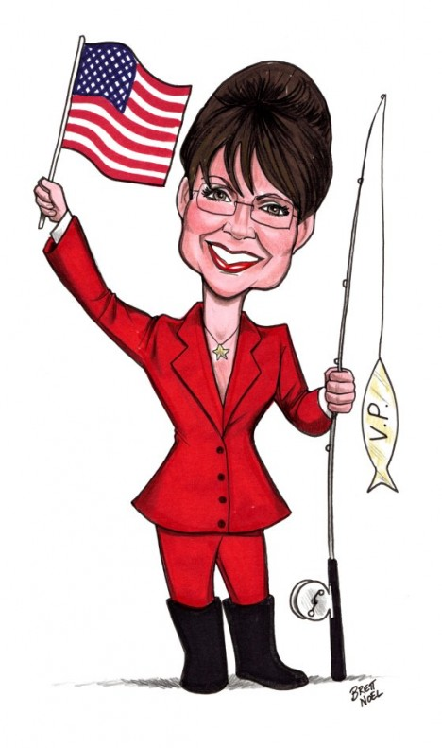
Soo...we had this idea. And it's fantastically AWFUL. In fact, there's only one name for it...HORRIBLE. Be here on April 16th to check out our newest, most outrageous theme night..The Rocky Horrible Picture Show. Come dressed as the most awful, disgusting person you can think of. How many Sarah Palin mama bears will be in the hizzouse? And what about Charlie Sheen and his goddesses? And let's not forget the classics, like Hitler...and Mel Gibson. We'll have a costume contest, prizes, and we're already planning a *very* special Trixie. So make sure you're here on April 16th to participate in the dreckitude.

We've been getting so many requests for our next theme night, we HAD to plan this one a couple of months early. Be sure to clear your calendar for May 14th, because Midnight Insanity will be bringing back 80's Night!! That's right, come celebrate the decade that most of you were born in (or after...*sigh*)by whipping out the hairspray, pulling on the shoulder pads, and breaking out the neon. This is a night you DON'T want to miss.

Like what you see? Want to join the eleganza that IS Midnight Insanity? Well lucky for you, we're always looking for some unsuspecting, innocent fools to corrupt. You don't get paid, but you get invited to our kick ass parties, meet some really awesome people, and you can channel your creativity into something besides that weekly-underwater-basket-weaving-class. So talk to Brandon or Mandi about what you need to do to join our little family...er cult...er cast. Yes, join our happy, harmonious, harmless little cast.
Brandon's Nonsensical Ramblings:
"Condragulations."

